Micro Aircraft
Assembly Manual

Team 18 - SAE Aero Micro Design Team
Ages 18+

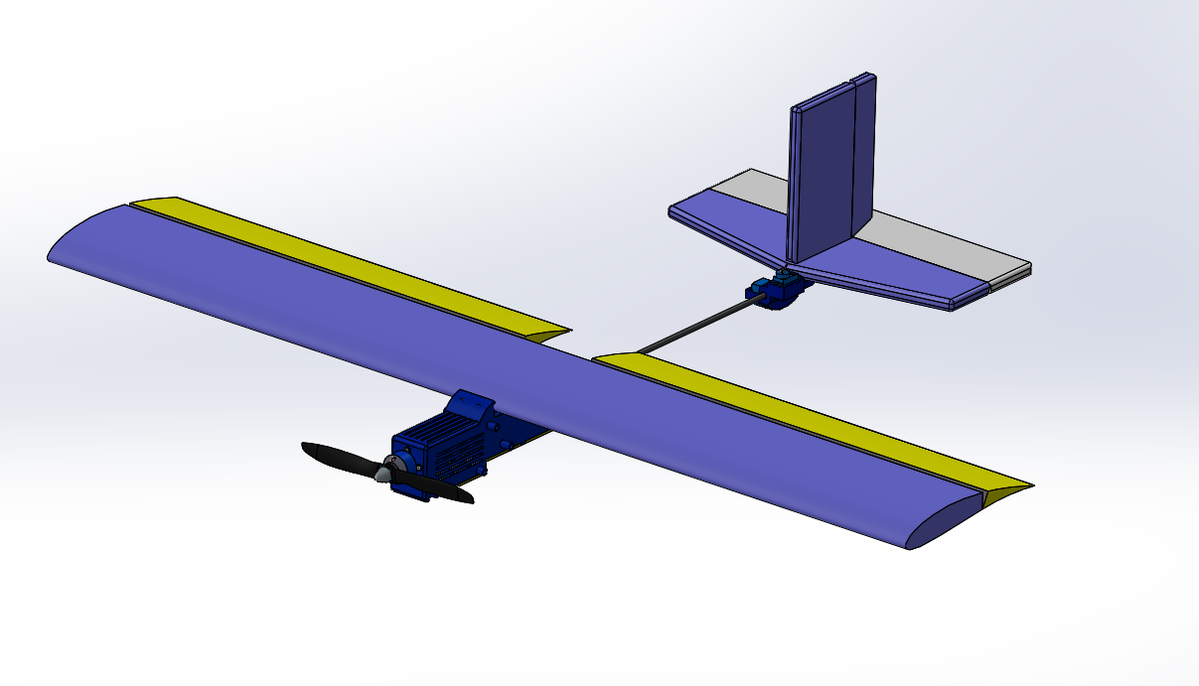

Submitted towards partial fulfillment of the requirements for
Mechanical Engineering Design



Department of Mechanical Engineering
Northern Arizona University
Flagstaff, AZ 86011

Parts not Included in Diagram

11. Controller (1)
12. Battery (1)
13. Wing Servos (2)
14. Horns (4)
15. Transmitter (1)

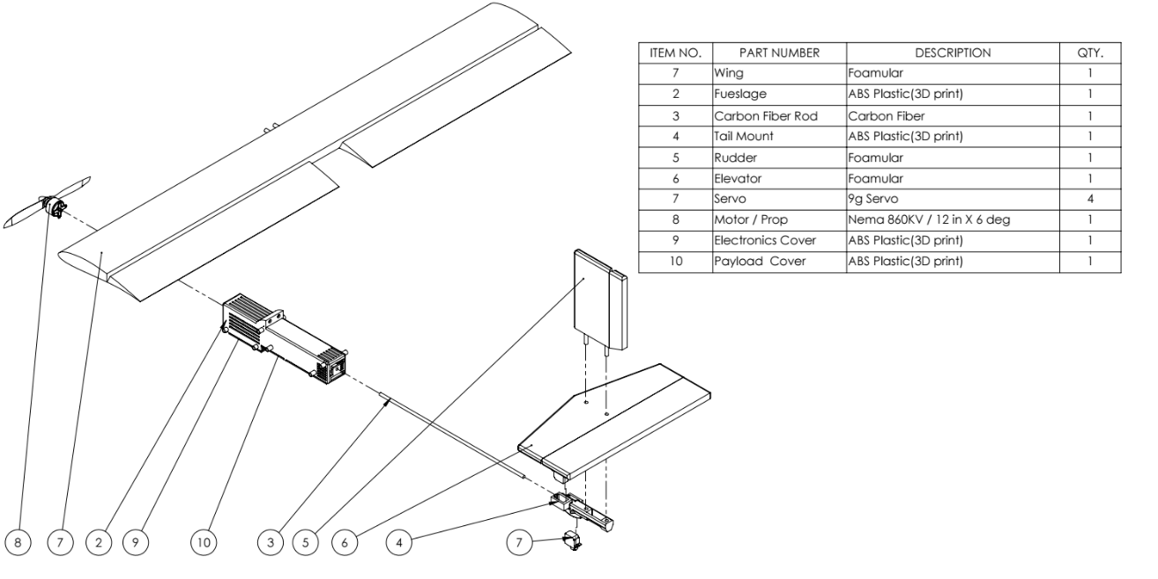

Assembly

- Attach ① to ② by inserting the two dowel rods on the front of the wing into the two holes located on the top of the fuselage.
- Secure the wing to the fuselage by wrapping rubber bands around the knobs on one side of the fuselage, stretch the rubber bands across the top of the wing, and wrap the rubber band around the knobs on the other side of the fuselage. Repeat this process with four rubber bands.
- Insert ③ into the circular hole on the back of ② about one inch (fully inserted).
- Insert the circular hole in ④ onto ③ about one inch (fully inserted). Make sure top of the tail mount is parallel with the top of the fuselage.
- Insert the two dowel rods on ⑤ into the two holes on the top of ⑥ until flush (as far as possible).
- Insert the dowel rods on ⑤ into the two circular holes on the top of 4 until the two small holes in the dowel rods are showing (as far as possible).
- Secure the horizontal stabilizer and rudder to the tail mount by inserting one pin into each small hole in the dowel rods on ⑤ (two pins total).
- Install ⑦ by placing two servos into the tail mount and placing two servos into the bottom of the wing. The servos for the tail mount are placed into the square holes, and the servos for the wing are placed into the square cutouts on the bottom of the wing.
- Fasten the tail mount servos with screws.
- Fasten the wing servos with reinforced tape.
- Secure ⑧ to ② with four screws on each corner of the engine mount. Make sure the corners of the engine mount are lined up with the corners of the fuselage.
- Secure ⑨ to the electrical compartment on bottom of ② by wrapping rubber bands around the knobs on one side of the fuselage, stretch the rubber bands across the electronics cover, and wrap the rubber band around the knobs on the other side of the fuselage. Repeat this process with four rubber bands.
- Secure ⑩ to the payload compartment on bottom of ② by wrapping rubber bands around the knobs on one side of the fuselage, stretch the rubber bands across the payload cover, and wrap the rubber band around the knobs on the other side of the fuselage. Repeat this process with four rubber bands.
- Assembly is now complete. Refer to “How to Operate” section for safety guidelines.

How to Operate
- Plug in the battery
- Plug in binding cable in the receiver. The receiver should blink, letting you know it is connected.
- Flip the training switch on the top of the controller and flip the switch in the middle of the controller to turn it on.
- Remove the binding cable.
- Make sure that the aileron, rudder, and elevators are horizontal when you do not touch the controller. If any of them are not balanced, refer to the website down below on how to calibrate the controller.
https://www.spektrumrc.com/ProdInfo/Files/SPM6600-Manual_DX6i.pdf

CAUTION!
DO NOT CONNECT THE BATTERY BEFORE YOU TURN ON THE CONTROLLER
DO NOT TOUCH THE PROPELLER WHILE THE BATTERY IS PLUGGED IN
FLY THE PLANE IN AN OPEN 300 FT AREA. MAKE SURE THERE ARE NO OBSTRUCTIONS, PEOPLE, OR ANY OTHER OBJECTS AROUND.
RISKS OF TOUCHING OPERATING PROPELLER INCLUDE MISSING LIMBS, PERMENENT EYE DAMAGE, AND POSSIBLE DEATH.
ALWAYS WEAR SAFETY GLASSES/GOGGLES AND A HELMET ANY TIME THE PLANE IN ON.
DO NOT KEEP THE BATTERY OR CONTROLLER IN WARM AND HUMID ENVIRONMENTS, POSSIBLE EXPLOSION OF THE BATTERY MAY OCCUR. SERIOUS BURNS MAY OCCUR IF NEAR EXPLODING BATTERY. KEEPING THE CONTROLLER IN A WARM ENVIRONMENT COULD CAUSE IT NOT TO FUNCTION PROPERLY.
WHEN LANDING, ALWAYS LAND THE PLANE IN A SOFT AREA LIKE GRASS.
DISCHARGE THE BATTERY AFTER EVERY USE.
DO NOT USE OLD OR DRY RUBBER BANDS
DO NOT USE LEAD IN ANY PART OF THE PLANE, THAT INTERFIERS WITH THE RADIO SIGNAL FROM THE CONTROLLER

